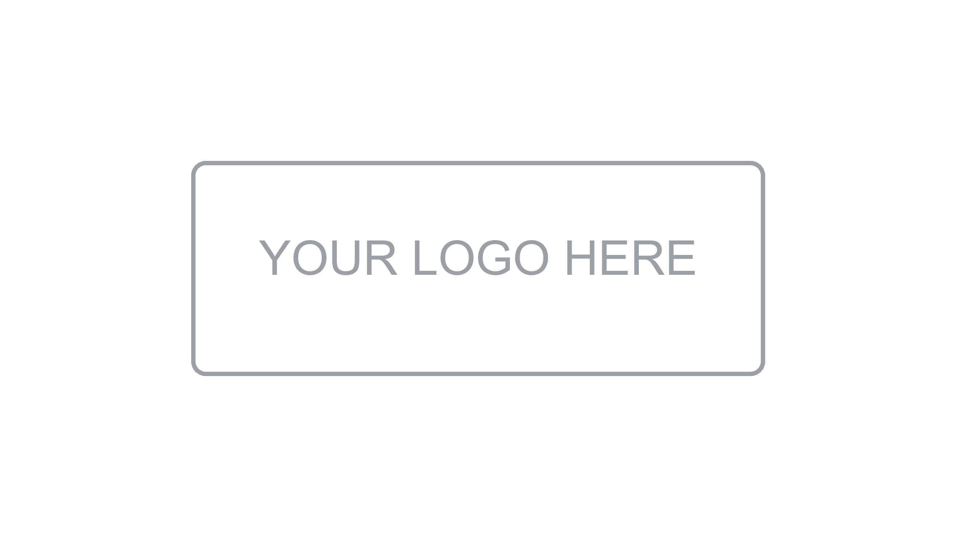

Evidence
Documentation

[Project Name]
Version [X.X] | [Month Year]
Prepared by: [Author Name] | [Team / Area]

About this document
Evidence Documentation

What is this document?
This document records all testing activities carried out for the system. It covers the testing strategy, test plan, individual test cases across all testing levels, test results, and the defect log. It serves as the formal evidence that quality validation was performed and provides traceability from requirements to test outcomes.
Who should read it?
This document is intended for QA engineers, developers, tech leads, product owners, and project managers who need to understand the testing approach, review test coverage, or assess quality before a release decision.
What does it contain?
Document Information & Change History | Version control, authorship, and revision log of this document.
Introduction | Purpose, scope, audience, and testing objectives.
Testing Strategy | Overall approach: testing levels, types, tools, and coverage goals.
Test Plan | Scope, schedule, resources, risks, and entry/exit criteria.
Test Cases — Unit Testing | Individual function and component-level test cases.
Test Cases — Integration Testing | Interface and service interaction test cases.
Test Cases — System & E2E Testing | Full system flow and end-to-end scenario test cases.
Test Cases — Non-Functional Testing | Performance, security, and usability test cases.
Test Results Summary | Aggregated results, pass/fail rates, and defect summary.
Defect Log | Catalog of defects found, their severity, status, and resolution.
References & Approvals | Related documents and formal sign-off section.

1. Document Information

Project | [Project Name]
Document Type | Evidence Documentation
Version | [X.X]
Test Cycle | [Cycle 1 / Regression / UAT]
Author(s) | [Name(s)]
Reviewer(s) | [Name(s)]
Date | [DD/MM/YYYY]
Status | [Draft / In Review / Approved]

2. Change History

Version | Date | Author | Description of Change
1.0 | [DD/MM/YYYY] | [Name] | Initial version

3. Introduction

3.1 Purpose
[Describe the purpose of this document. Example: This document provides the complete testing evidence for the [Project Name] system, demonstrating that all functional and non-functional requirements have been validated prior to release.]

3.2 Scope
[Define what is included in this test cycle. Example: This document covers unit, integration, system, and performance testing for version [X.X] of the [Project Name] system. UAT is out of scope for this cycle.]

3.3 Testing Objectives
- Verify that all functional requirements are correctly implemented
- Validate non-functional requirements (performance, security, usability)
- Identify and track defects to resolution before release
- Provide traceability between requirements and test outcomes
- Support the release decision with documented evidence

3.4 Definitions
Term | Definition
TC | Test Case — a defined set of inputs, conditions, and expected results
TR | Test Result — the outcome of executing a test case
Defect | A deviation from the expected behavior defined in requirements
Pass | The actual result matches the expected result exactly
Fail | The actual result does not match the expected result
Blocked | The test could not be executed due to a dependency or environment issue
Skipped | The test was intentionally not executed in this cycle
Severity | Impact of the defect on system functionality (Critical / High / Medium / Low)
Priority | Urgency of fixing the defect relative to the release (P1–P4)

4. Testing Strategy

4.1 Testing Levels
Level | Description | Owner | Automation
Unit Testing | Tests individual functions and components in isolation | Developers | Yes — Jest / JUnit / PyTest
Integration Testing | Tests interactions between modules, APIs, and services | Developers / QA | Yes — Postman / Rest Assured
System Testing | Tests the complete system end-to-end against functional requirements | QA Team | Partial — Cypress / Selenium
Performance Testing | Validates response times, throughput, and system behavior under load | QA / DevOps | Yes — k6 / JMeter
Security Testing | Validates authentication, authorization, and vulnerability exposure | QA / Security | Partial — OWASP ZAP
UAT | End-user validation of business scenarios and acceptance criteria | Business / PO | No — Manual

4.2 Testing Types
- Functional Testing — verifying system behavior against requirements
- Regression Testing — ensuring new changes do not break existing functionality
- Smoke Testing — quick post-deployment check to confirm basic functionality
- Exploratory Testing — unscripted testing to discover unexpected behavior
- Boundary Testing — validating behavior at input limits and edge cases

4.3 Test Tools
Tool | Purpose | Used For
[Jest / JUnit / PyTest] | Unit test framework | Unit Testing
[Postman / Rest Assured] | API testing | Integration Testing
[Cypress / Selenium] | UI & E2E automation | System / E2E Testing
[k6 / JMeter] | Load and performance testing | Performance Testing
[OWASP ZAP] | Security scanning | Security Testing
[Jira / Azure DevOps] | Defect tracking | All levels
[SonarQube] | Static code analysis | Code quality

4.4 Coverage Goals
Level | Coverage Target | Measurement
Unit Testing | 80% code coverage minimum | Line / branch coverage via coverage report
Integration Testing | 100% of API endpoints | All endpoints tested with valid and invalid inputs
System Testing | 100% of functional requirements | Traceability matrix — all FRs covered by at least one TC
Performance | Meets NFR targets | Response time and throughput benchmarks

5. Test Plan

5.1 Test Scope
[List what is in scope and out of scope for this test cycle.]

In Scope | Out of Scope
All functional requirements from version [X.X] | Third-party integrations not under team control
All API endpoints defined in the API documentation | Legacy system compatibility (separate effort)
Performance testing up to [N] concurrent users | Full security penetration test (separate engagement)
[Additional in-scope item] | [Additional out-of-scope item]

5.2 Test Schedule
Phase | Start Date | End Date | Owner
Test Case Design | [DD/MM/YYYY] | [DD/MM/YYYY] | [Name]
Unit Testing | [DD/MM/YYYY] | [DD/MM/YYYY] | [Name]
Integration Testing | [DD/MM/YYYY] | [DD/MM/YYYY] | [Name]
System Testing | [DD/MM/YYYY] | [DD/MM/YYYY] | [Name]
Performance Testing | [DD/MM/YYYY] | [DD/MM/YYYY] | [Name]
UAT | [DD/MM/YYYY] | [DD/MM/YYYY] | [Name]
Defect Fixing | [DD/MM/YYYY] | [DD/MM/YYYY] | [Name]
Sign-off | [DD/MM/YYYY] | [DD/MM/YYYY] | [Name]

5.3 Entry and Exit Criteria
Criteria Type | Condition
Entry — Unit | Code merged to main branch and build passing
Entry — Integration | All unit tests passing and services deployed to test environment
Entry — System | Integration tests passing and test data prepared
Entry — UAT | System tests passed with no Critical/High open defects
Exit — All phases | 100% of planned test cases executed
Exit — All phases | No open Critical defects; High defects have approved workaround
Exit — All phases | Test results reviewed and signed off by QA Lead

5.4 Risks and Mitigations
Risk | Probability | Impact | Mitigation
Test environment instability | Medium | High | Dedicated test environment with daily health checks
Incomplete requirements | Medium | High | Early requirements review with QA participation
Resource unavailability | Low | Medium | Cross-training and backup assignment
Late delivery of features | Medium | High | Risk-based test prioritization
[Additional risk] | [P] | [I] | [Mitigation]

6. Test Cases — Unit Testing
[Unit tests validate individual functions and components in isolation. Each test case targets a single unit of logic.]

TC ID | Component / Function | Description | Expected Result | Status
TC-U-001 | [ClassName.methodName] | [Verify that the function returns the correct value when given valid input] | [expected output] | Pending
TC-U-002 | [ClassName.methodName] | [Verify that the function throws an exception when input is null] | Exception thrown | Pending
TC-U-003 | [ClassName.methodName] | [Verify behavior at boundary value — minimum and maximum allowed input] | [expected output] | Pending
TC-U-004 | [ClassName.methodName] | [Verify that the function handles empty input gracefully without crashing] | [expected output] | Pending

7. Test Cases — Integration Testing
[Integration tests validate the interactions between modules, services, and APIs. Focus on data flow, contracts, and error handling across boundaries.]

TC ID | Endpoint / Interface | Scenario | Expected Response | Status
TC-I-001 | POST /[resource] | Create resource with valid payload | 201 Created + resource body | Pending
TC-I-002 | POST /[resource] | Create resource with missing required field | 400 Bad Request + error message | Pending
TC-I-003 | GET /[resource]/{id} | Retrieve existing resource by ID | 200 OK + resource body | Pending
TC-I-004 | GET /[resource]/{id} | Retrieve non-existent resource | 404 Not Found | Pending
TC-I-005 | DELETE /[resource]/{id} | Delete existing resource | 204 No Content | Pending
TC-I-006 | [Service A] → [Service B] | Verify event published on record creation | Event received by consumer | Pending

8. Test Cases — System & E2E Testing
[System tests validate complete user-facing flows from end to end, ensuring all components work together to deliver the expected business outcome.]

TC ID | Scenario | Steps | Expected Result | Status
TC-S-001 | [Happy path: complete [core flow] successfully] | 1. [Step 1]  2. [Step 2]  3. [Step 3]  4. [Step 4] | [System completes the flow and shows confirmation] | Pending
TC-S-002 | [Negative: [core flow] with invalid data] | 1. [Step 1]  2. Enter invalid data  3. Submit | [System shows validation error and does not proceed] | Pending
TC-S-003 | [Edge case: [flow] with maximum allowed values] | 1. [Step 1 with max values]  2. [Step 2] | [System processes boundary data correctly] | Pending
TC-S-004 | [Concurrent: [flow] by multiple users simultaneously] | 1. Execute [flow] from 10 concurrent sessions | [All sessions complete without data corruption] | Pending

9. Test Cases — Non-Functional Testing

9.1 Performance Testing
TC ID | Scenario | Load Profile / Duration | Pass Criteria | Status
TC-P-001 | Baseline response time under normal load | 50 concurrent users / 10 min | P95 < 2s, error rate < 1% | Pending
TC-P-002 | Peak load test | 200 concurrent users / 30 min | P95 < 3s, error rate < 2% | Pending
TC-P-003 | Stress test — find system breaking point | Ramp to 500+ users / 20 min | System degrades gracefully | Pending
TC-P-004 | Endurance / soak test | 100 concurrent users / 4 hours | No memory leaks or degradation | Pending

9.2 Security Testing
TC ID | Scenario | Expected Result | Status
TC-SEC-001 | Access protected endpoint without token | 401 Unauthorized | Pending
TC-SEC-002 | Access resource with expired JWT token | 401 Unauthorized | Pending
TC-SEC-003 | Access another user resource with valid token | 403 Forbidden | Pending
TC-SEC-004 | SQL injection attempt in form and API inputs | Input sanitized — no DB error | Pending
TC-SEC-005 | XSS script injection in text input fields | Input escaped — no execution | Pending
TC-SEC-006 | HTTP request to application — verify HTTPS redirect | Redirect to HTTPS (301) | Pending

10. Test Results Summary
[Complete this section after all test cases have been executed. Summarize the outcomes by testing level.]

Testing Level | Total TCs | Passed | Failed | Blocked | Skipped | Pass Rate
Unit Testing | [N] | [N] | [N] | [N] | [N] | [%]
Integration Testing | [N] | [N] | [N] | [N] | [N] | [%]
System / E2E | [N] | [N] | [N] | [N] | [N] | [%]
Performance | [N] | [N] | [N] | [N] | [N] | [%]
Security | [N] | [N] | [N] | [N] | [N] | [%]
Total | [N] | [N] | [N] | [N] | [N] | [%]

📋 Note
A release decision should not be made with open Critical or High severity defects unless a formal risk acceptance has been documented and approved by the Product Owner and Tech Lead.

11. Defect Log
[Log all defects found during testing. Update status as defects are fixed and re-tested.]

ID | Title | Severity | Priority | Related TC | Found In | Status | Assigned To
DEF-001 | [Short description of the defect] | Critical | P1 | TC-S-001 | [Module / Version] | Open | [Name]
DEF-002 | [Short description of the defect] | High | P2 | TC-I-003 | [Module / Version] | In Progress | [Name]
DEF-003 | [Short description of the defect] | Medium | P3 | TC-U-002 | [Module / Version] | Fixed | [Name]
DEF-004 | [Short description of the defect] | Low | P4 | TC-S-003 | [Module / Version] | Closed | [Name]

11.1 Defect Severity Guide
Severity | Definition | Example
Critical | System unusable or data loss — blocks release | Application crash, data corruption, auth bypass
High | Major feature broken with no workaround | Core business flow fails, key API returns 500
Medium | Feature partially broken, workaround exists | UI element misaligned but functional, wrong label
Low | Minor cosmetic or non-blocking issue | Typo, minor style inconsistency

12. References and Related Documents
Document | Description | Location / Link
Requirements Documentation | Source requirements for traceability | [Link / Path]
Architecture Documentation | System design reference | [Link / Path]
API Documentation | Endpoint reference for integration tests | [Link / Path]
Installation Manual | Environment setup for test infrastructure | [Link / Path]
[Other Document] | [Description] | [Link / Path]

13. Approval

Role | Name | Signature | Date
QA Lead | [Name] |  | [DD/MM/YYYY]
Tech Lead | [Name] |  | [DD/MM/YYYY]
Product Owner | [Name] |  | [DD/MM/YYYY]
Project Manager | [Name] |  | [DD/MM/YYYY]

